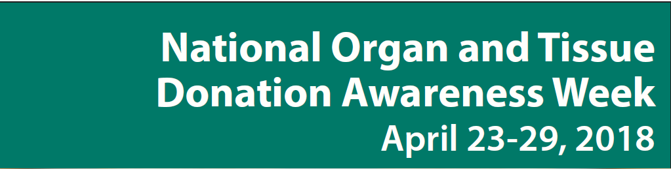

Help Us Spread the Word: Celebrate #NOTDAW on Social Media!
Please consider sharing these messages to help us raise awareness for National Organ and Tissue Donation Awareness Week – April 23-29
- You have the green light to give! It’s National Organ and Tissue Donation Awareness Week. Register your decision to donate online at organtissuedonation.ca #NOTDAW
- National Organ and Tissue Donation Awareness Week is the perfect time to talk to your family about your decision to donate and ask your loved ones about their wishes. Visit organtissuedonation.ca #NOTDAW
- This week honour those who’ve saved a life by joining the online conversation about organ donation. Encourage others to register their decision to donate. Use the hashtag #NOTDAW and go to organtissuedonation.ca
- It's National Organ & Tissue Donation Awareness Week #NOTDAW. Learn how you can become a donor at organtissuedonation.ca
- #NOTDAW celebrates organ & tissue donors to raise awareness about the critical need for more donors in #Canada. Help spread the word!
- Help celebrate #NOTDAW by registering your decision – you could save a life. organtissuedonation.ca
- It’s #NOTDAW. Talk to your family about your organ and tissue donation wishes. https://organtissuedonation.ca
- Living donation saves lives too - donating a kidney or a portion of your liver can save a life.
- It’s #NOTDAW – “thank you” to organ and tissue donors across Canada for their gift of life.
For more information please visit https://blood.ca/en/media/resource/national-organ-and-tissue-donation-awareness-week

