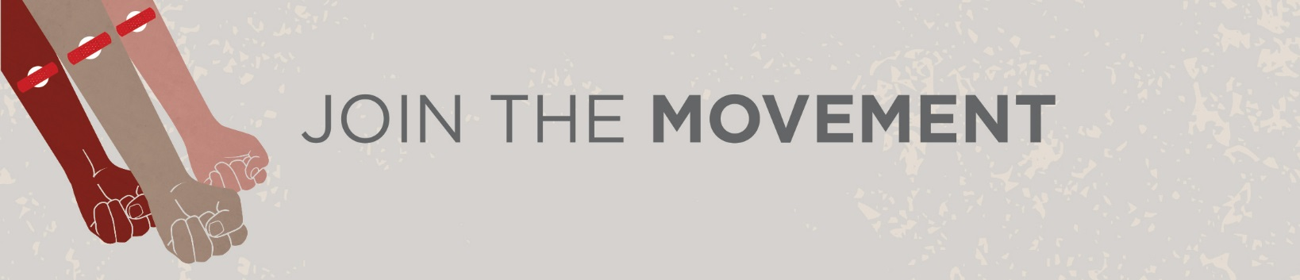

**Announcement Idea(s):**

**Can you spare an hour of your time to help save a life?**

Someone’s life is depending on it. That someone could be a friend, a family member, fellow colleague, or perhaps even you….

If you haven’t considered donating before, now is the time to join the movement. There’s a <Name of School> blood donor clinic held (in or at) <Location> on <Date> from <Hours of Clinic>.

Tap into your inner hero and sign up to give life today.

**It can take up to 50 donors to help the victim of a single car crash -   
You can be one of those donors!**Blood transfusions are a critical element of resuscitating trauma patients. Blood donors are a critical element of saving those patients lives. Recruit your friends and family to register at blood.ca to find out if you are eligible to donate and give the gift of life.

**Let’s Join the Movement <Insert School Mascot Name>**

Did you know only 25% of patients needing a stem cell transplant will find a donor in their family? Currently, there are over 1,000 patients in Canada waiting for a stem cell transplant.

Canadian Blood Services is hosting a stem cell swabbing event in the <location> on <Insert Date> from <Insert Time>.

Be the match on <event date> by getting swabbed!

**Are you an A, an O or a B? Are you a positive or negative person?**

Not many people know their blood type but on <insert date> you can find out! Canadian Blood Services will be hosting a blood typing event at <location> If you are 17 and over and want to learn more about how you can join the movement and give life, this event is the place for you!

**Over half of all Canadians say that they or a family member have needed blood at some point in their lives.  
Let this be the point in YOUR life where you make a difference for Canadians in need.**  
  
Blood is used to help cancer patients through treatment and trauma victims through surgery.   
You can help by taking part in donor recruitment event on <insert date> at <insert location>   
  
Blood can’t be replaced by anyone other than you. It’s that simple. You have the power to join the movement and become a valued blood donor today!  
For more information or to learn more about blood donation visit [www.blood.ca](http://www.blood.ca)**.**

There are many reasons that people may not donate blood: a fear of needles, inconvenience or no time to spare or **“no one asked me to help”.**  
  
<Insert school name> is asking for your help now! You can take part in the donor recruitment event on <insert date>.

The minimum age to donate blood is 17 but you can join the movement at any age! You can help recruit friends and family, or volunteer at one of our clinic events.   
<Insert clinic events>   
Talk to our champion <Insert YDC name> about booking an appointment, or sign up at [www.blood.ca](http://www.blood.ca).

Canadians are counting on you, and our school is too! Join the movement.

**Let’s Get Social. Let’s #GiveLife:**

 Like us on Facebook/canadianbloodservices

 Follow us on twitter @itsinyoutogive Use the hashtag #GiveLife

Instagram /canadianbloodservices

Don’t forget to download the free Canadian Blood Services GiveBlood App

